**AndroidX Migration**

When you create a Xamarin forms project, these will be some of the packages installed by default in Android Project. (Droid>right click>Manage NuGet Packages)

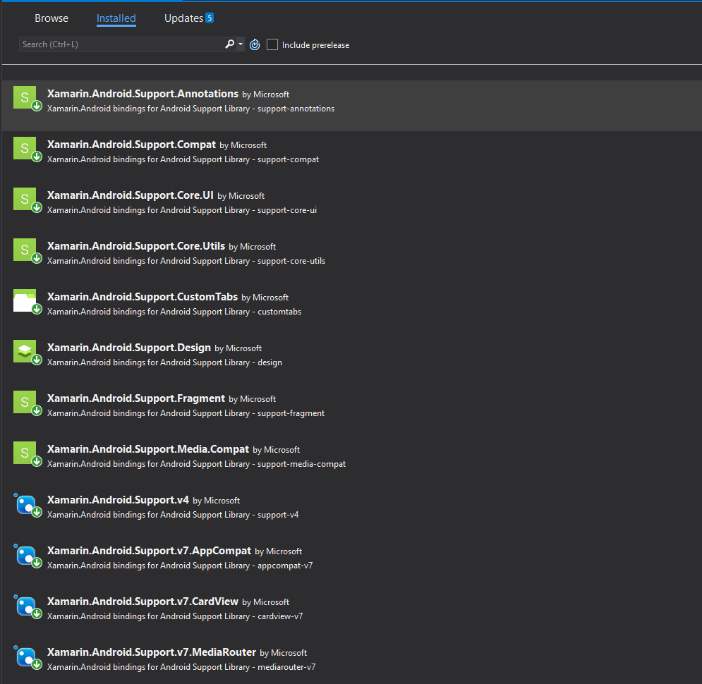

If you’re using these packages of ‘Android Support Library’ in your Android project, at some point you will soon have to migrate to another new library, since ‘Android Support Library’ is no more maintained.

The most recent library is ‘AndroidX’ which has much more library support than the old one. The apps work fine with the old library, but I had to change my android project to use ‘AndroidX’ since I needed to use the new ‘Biometrics’ libraries which were not included the ‘Android Support Library’, but were included in ‘AndroidX’.

Don’t uninstall the old libraries. You will not have to change anything in your code. Open **MainActivity.cs**, put a break point in **OnCreate()** method and start the emulator. When you check the base class of your **MainActivity**, you can see that it refers to **Android.Support.V7**, which is the old library.

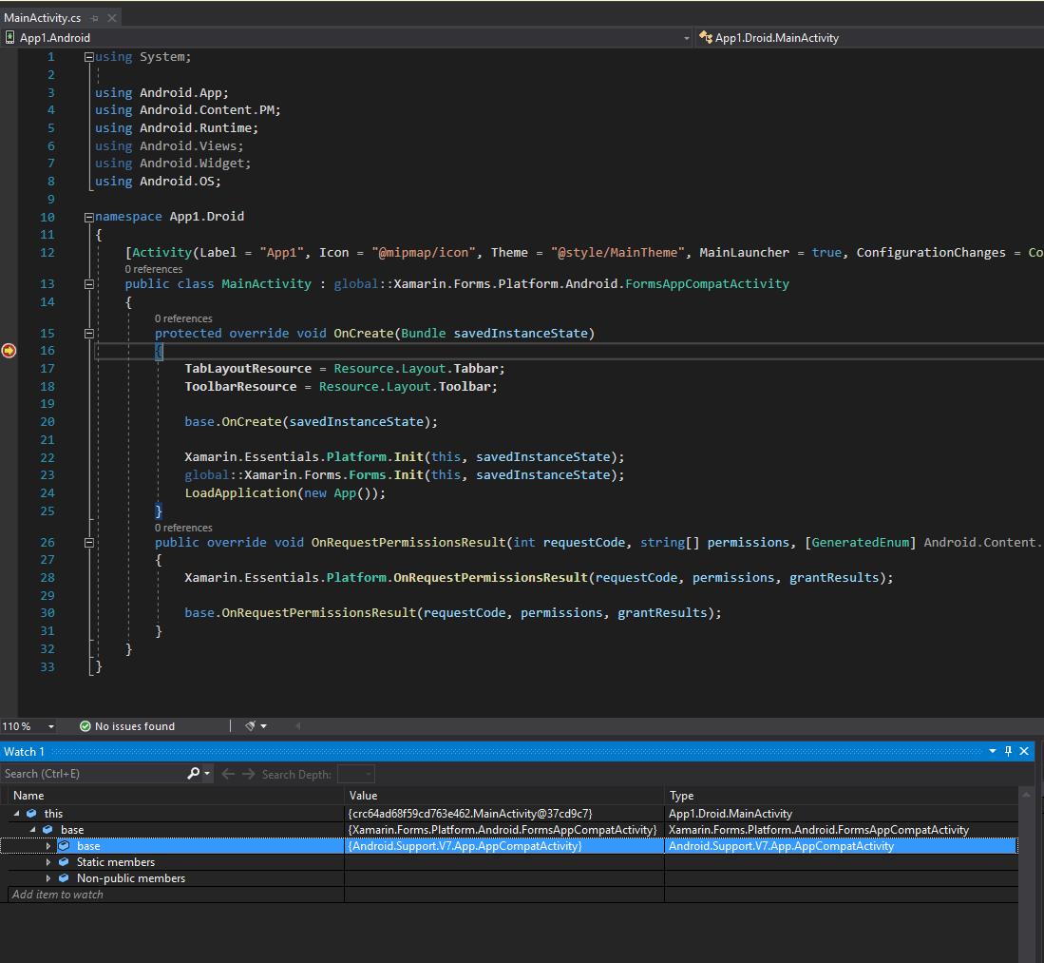

Let’s change this to refer to the new **AndroidX** library. Here are the simple steps for migrating Android project to support **AndroidX**.

1. Open ‘Application’ (Droid>right click>Properties>Application), make sure the ‘**Compile using Android version: (Target Framework)’** is set to **Android 10.0 (Q)\*** or greater. Hit ‘Yes’ on the pop up and then you should be prompted with new Android SDK installation, if you haven’t already installed it. So just install the required SDK…

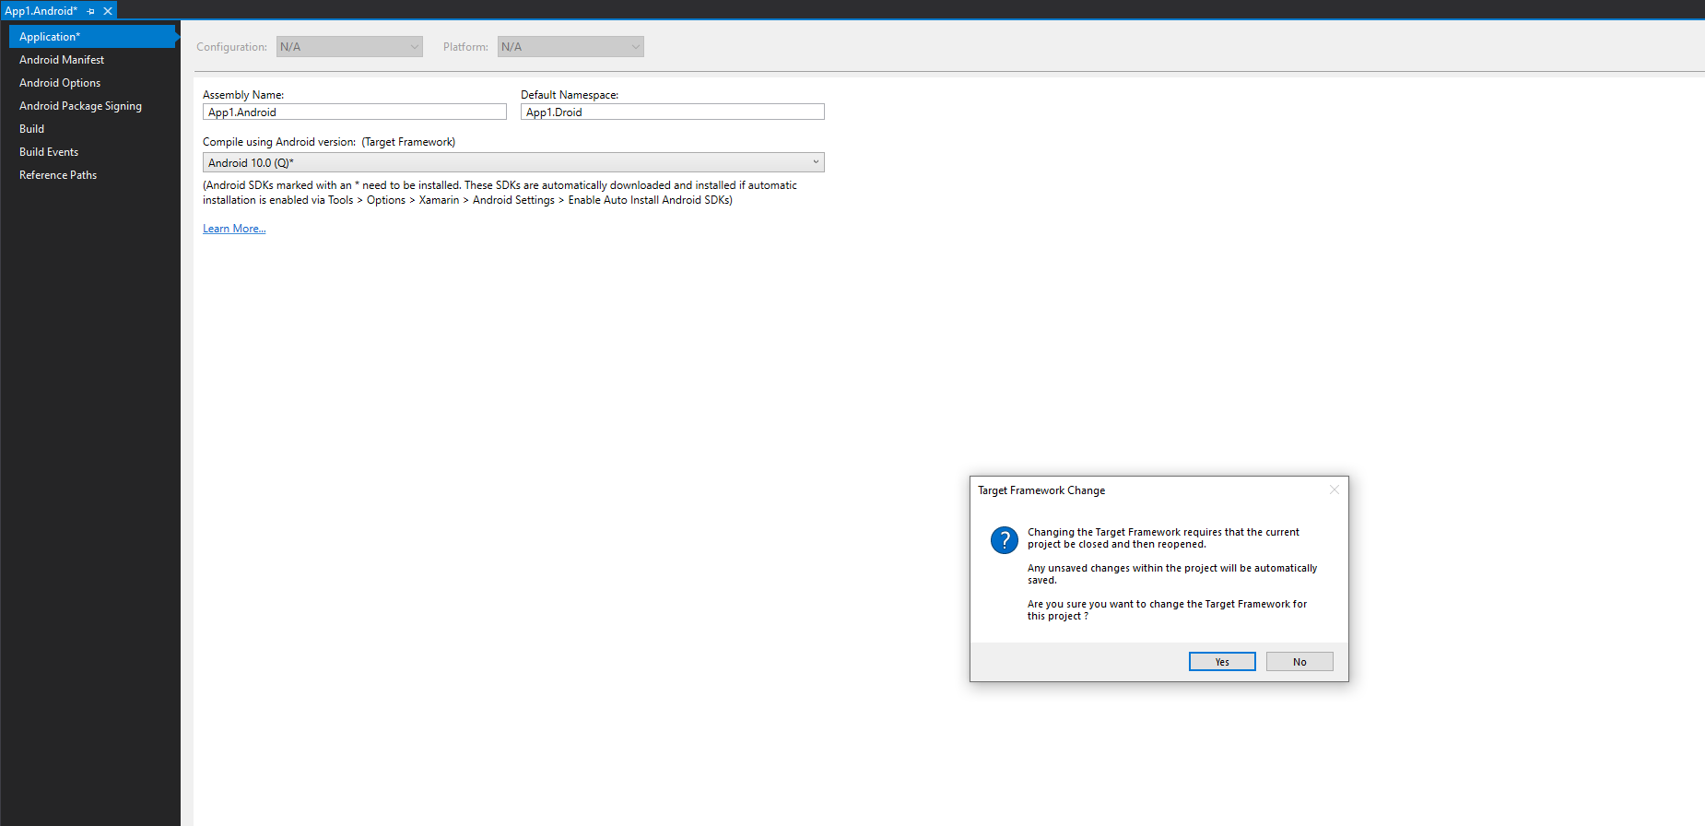

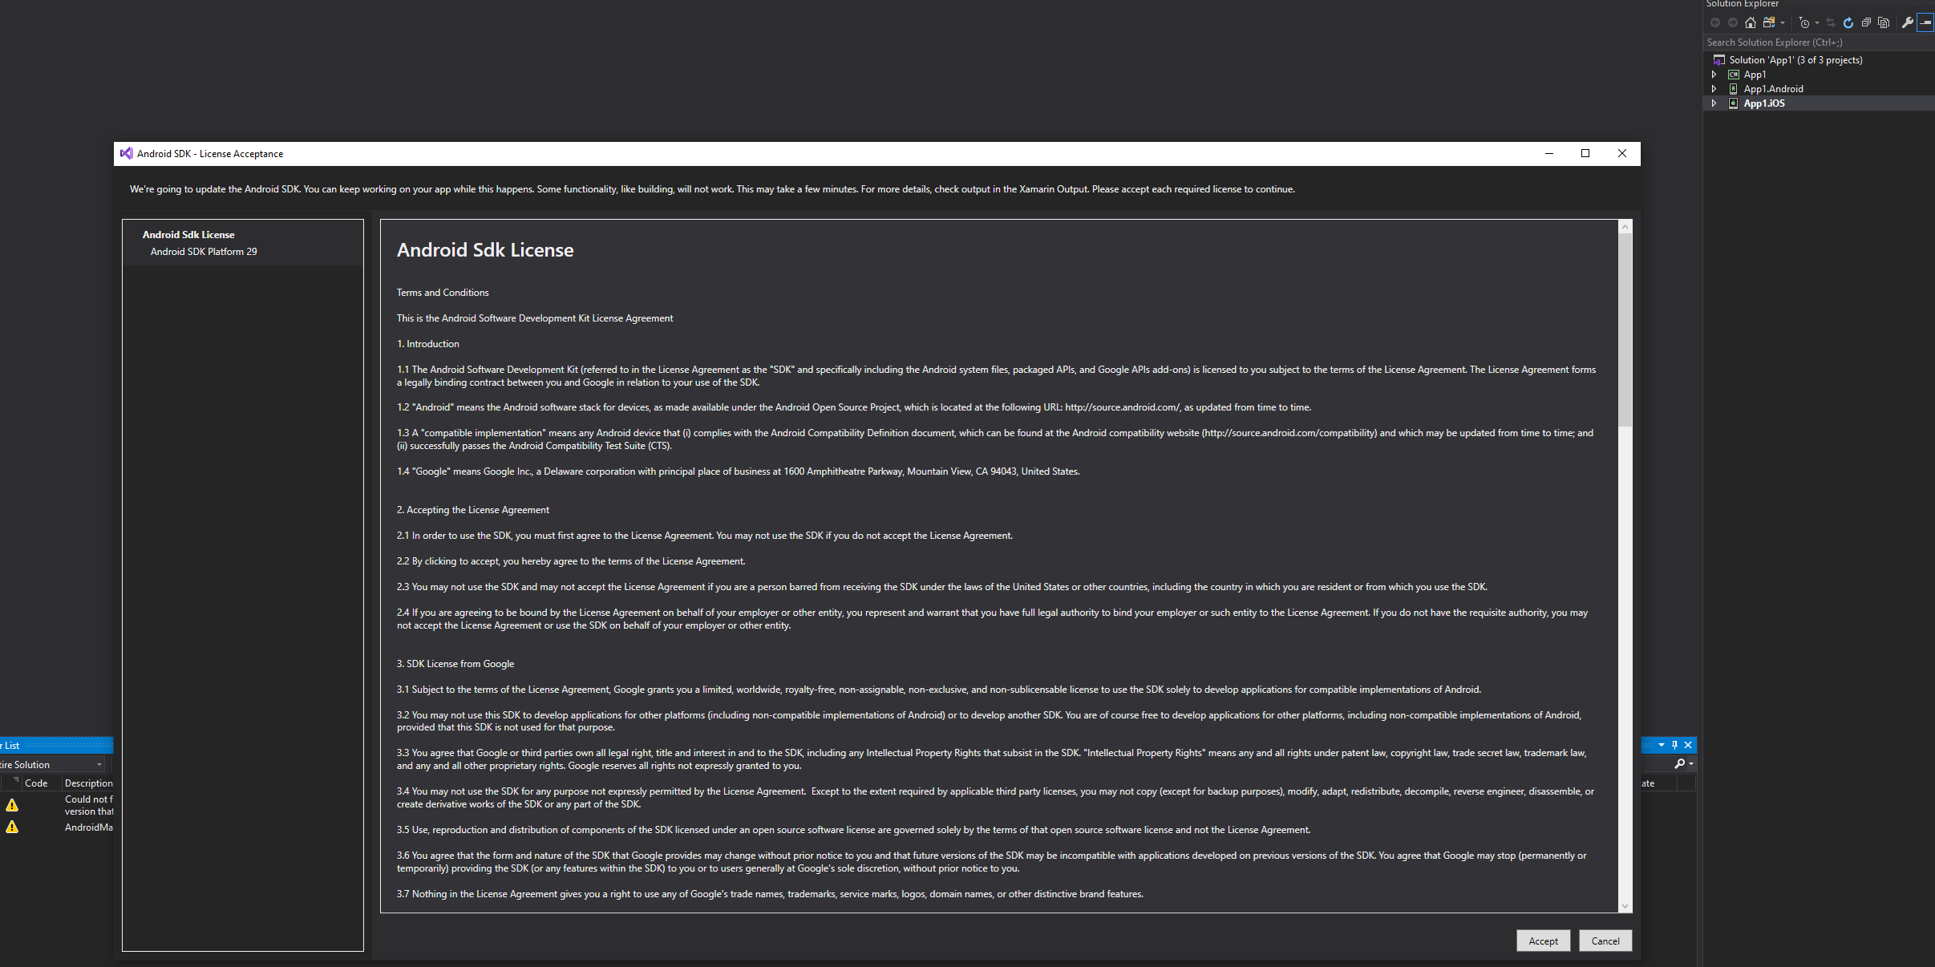

1. Now open ‘Android Manifest’ and check the ‘Target Android version’. It should be same as the target version that you have selected in the above step.

(Droid>right click>Properties>Android Manifest)

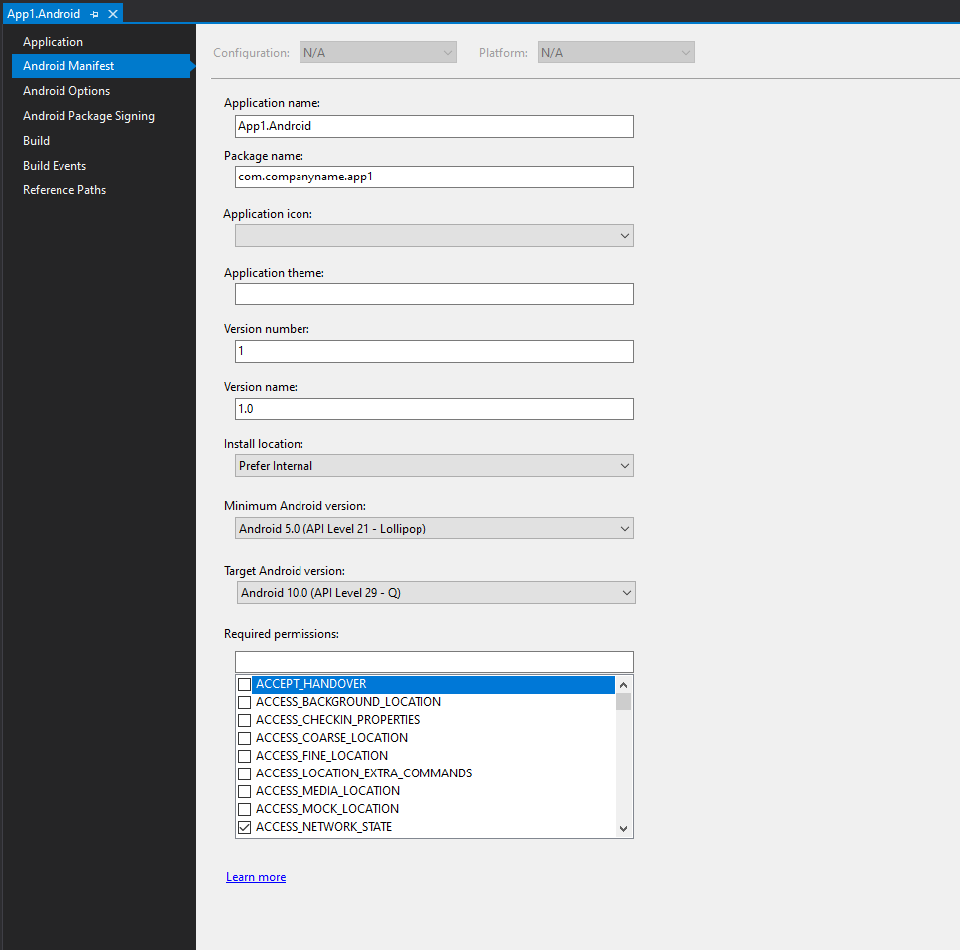

1. Enable the **AndroidX Migrator** via **Tools > Options > Xamarin > Android Settings**  
     
   Check out <https://docs.microsoft.com/en-us/xamarin/android/platform/androidx> to see how to added the Migrator tool.
2. Right-click your project and you will see **Migrate to AndroidX listed, click on it. Once the migration process is completed, you might get some missing package errors, if so, install those missing packages. Also if open the NuGet Packages of your project, you will notice all your old ‘Android Support’ libraries are not changed to ‘AndroidX‘ libraries.**
3. **You are all set. Now start the emulator again and check the same MainActiviy**’s base class. You will notice it now refers to **AndroidX**.

